trunk.bat - Usage
Set your path on line 3 -- I was using drive Q: root folder
Set your desired file extension on line 4 -- I was interested in Python files, hence the *.py
Set your delimiter on line 5 -- I was interested in the underscore _
Place trunk.bat in the same folder as the files unzipped from Moodle. For example, I chose 'Download all submissions' on Moodle thus giving me a *.zip file. Next I unzipped the files to drive Q: root folder.
Once trunk.bat and the files are in the same folder simply type 'trunk'
That is all!
Below is a screenshot of what happened:
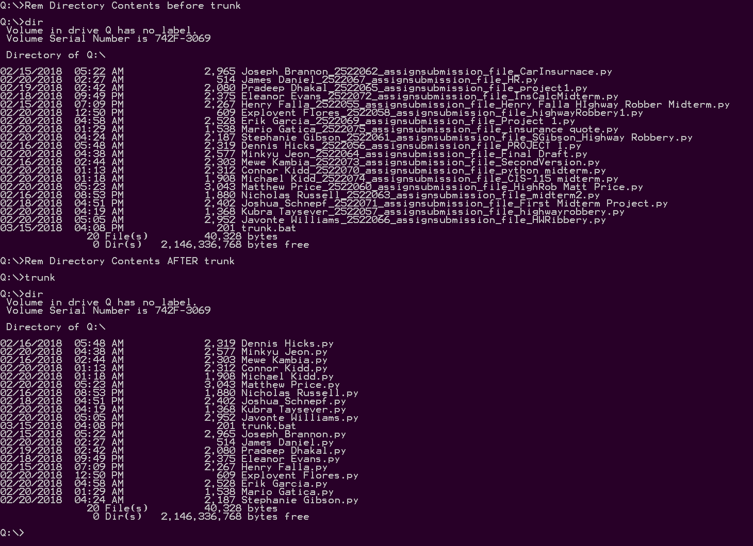
I hope that helps,
Jim

